FIN 608 Project 1

Group 2

# 1 Background

The total asset growth anomaly indicates a negative relationship between return on equity and the annual growth rate of the total asset in the subsequent one year. Which means, firms and companies with relatively fast rate of total asset growth are expected to produce relatively poor return on equity in the next year or the next given time period. The given set of stocks contains rank of annual total asset growth among the stocks. It contains 300 non-financial stocks with highest growth of total asset in the previous year, and another 300 non-financial stocks with lowest growth of total asset. The former subset would be treated as the pool of short candidates, while the later subset would be treated as the pool of long positions. Based on previous finding, the TAGA filter provides us two portfolios each contains 300 stocks.

In this project, we aim to further reduce the number of stocks within each portfolio and establish two new portfolios which contain 50 chosen short candidates, and 50 chosen long candidates respectively. Their weights are equal to each other, and remain unchanged. The initial endowment of the portfolio is $500K with an initial short position of $3K on each short candidate and an initial long position of $13K on each of the 50 long candidates, inclusive all transaction cost.

# 2 Data and Algorithm

Since our goal is to trim the size of the given two portfolios from 300 to 50, a new filter could be designed. Also, based on the fact that our candidates are non-financial firms, accounting factors could act as relative good indicators of their performance. Therefore, we examined the following factors for long and short candidates respectively.

## 2.1 Long Position Candidates

The following are chose factors along with the reasons for choosing them.

### 2.1.1 Total Asset Change

Data: (2018 total asset - 2017 total asset) / (2017 total asset)

A huge total asset reduction, say greater than 80%, may indicate a major loss or a reorganization, which creates uncertainty without knowing the firm’s future strategy. Hence, these candidates are excluded for safety purpose.

### 2.1.2 Research and Development Cost / Total Asset

Data: (2018 Research and Development Cost) / (2018 Total Asset)

The ratio of (Research and Development Cost) / (Total Asset) indicates the percentage of cost of research and development in total asset. If this ratio is relatively high, it would show that the firm invests a lot of fund on research, and pays more attention on Research and Development. The firms with this trait are more likely to have promising futures than those with relatively less Research and Development spending. In other words, firms with higher ratio would have greater chances to develop in future, and a higher probability for their market value to move up. Hence, excluding stocks with relative low R&D / A would be a reasonable choice for a long position.

### 2.1.3 The Change of Debt / Assets Ratio

Data: (2018 Debt) / (2018 Assets) – (2017 Debt) / (2017 Assets)

The Change of Debt / Assets Ratio indicates that the movement of percentage of Debt over Assets, in other words, the percentage of Equity over Assets increases if the Change of ratio is negative. Since the ratio of E / A increasing, we would consider that the equity’s value has tend to increase, which means the probability of increasing would be relatively higher compared with those with positive Change of D / A Ratio. Hence, we would exclude those stocks with positive Change of D / A Ratio.

## 2.2 Short Position Candidates

For the Short Position Candidates, we would focus on the following factors, and the reasons for choosing them coming up respectively.

### 2.2.1 Decrease in Price in the Past Quarter

Data: (2018 Price)

If the price of a certain stock has decreased too much, like 90% in the past three months, we will move it out of the short candidate portfolio. We are worried that the large drop in the past may have made the stock to be undervalued and besides, revengely rebounce may occur and the return/risk ratio is too low.

### 2.2.2 EPS

Data: (2018 EPS) and (2017 EPS)

Earnings per share (EPS) is the portion of a company's profit allocated to each share of [common stock](https://www.investopedia.com/terms/c/commonstock.asp). Earnings per share serves as an indicator of a company's profitability. If EPS is too low, it means that the company may have difficulty in generate profits. Hence, it should be a short candidate.

### 2.2.3 Price/Earing Ratio

Data: (2018 P/E Ratio) and (2017 P/E Ratio)

The price-earnings ratio (P/E ratio) is the ratio for valuing a company that measures its current share price relative to its per-share earnings. The price-earnings ratio is also sometimes known as the [price multiple](https://www.investopedia.com/terms/p/pricemultiples.asp) or the earnings multiple. In general, a high P/E can indicate either that a company may currently be overvalued or that investors are expecting higher earnings growth in the future.

### 2.2.4 The Change of Debt / Assets Ratio

Data: (2018 Debt) / (2018 Assets) – (2017 Debt) / (2017 Assets)

The reason is similar to that in long position part, while the criterion would be the opposite. We exclude those stocks with negative Change of D / A Ratio.

# 3. BACK TEST

Portfolio performance is tested starting from single factor filters to multi-factor filters. For single factor filters, we only provide filtering criteria and final return, and a comparison with benchmark, which is the 300-stock portfolio return (that is, if it is a long candidate filter, we would compare its return with the return of portfolio containing all 300 long candidates; and the same comparison would be done for short candidates); for multi-factor filters, a more thorough explanation would be provided.

One thing need to specify is that, for single factor filters, we aim to find out whether some specific filters are valid for prediction purpose; therefore the result may yield a portfolio of more than 50 stocks.

For multi-factor filters, we will combine the valid factors and design a new threshold to constrain the candidate number to exact 50. The threshold of factors is determined by the combination of the number of stocks that we needed, parameter optimization and some artificial arts.

## 3.1 Long Portfolio Single Factor Test

For long portfolio, the benchmark return is -12.33%. For the following factors, if the filter results in a portfolio of return higher than -12.33%, we would consider it an applicable factor; otherwise we would consider it inapplicable.

### 3.1.1 Research and Development Cost / Total Asset

We picked the stocks that have the Research and Development Cost/Total Asset ratio greater than 10%. There are 156 stocks remaining in total with an average return of -0.105.

### 3.1.2 Delta D/A filter

We remove the stocks that have positive delta D/A ratio from the long portfolio. For those stocks that do not have delta D/A ratio or equals to zero, we also remove them. There are 176 stocks remaining in total and the average return is -0.13 over the last quarter.

### 3.1.3 Current Ratio

We set the threshold to be 4, we remove all the stocks that are less than 4. For the remaining 96 stocks, the return is -0.095, which is greater than that of benchmark.

## 3.2 Short portfolio Single Factor Test

### 3.2.1 Delta D/A filter

We remove the stocks that have negative delta D/A ratio from the short portfolio. For those stocks that do not have delta D/A ratio or equals to zero, we also remove them.

There are 180 stocks remaining in total and the average return for this portfolio is 0.126 over the last quarter.

### 3.2.2 EPS

If EPS is less than -2, then we will add the stocks into the short portfolio. There are 66 stocks in total and the return of the portfolio in the last quarter is 22.6%. We can see that this factor almost doubles the return of the portfolio.

### 3.2.3 Administration cost

We use administration cost over assets as an indicator to pick some candidate stocks. Since we found that there is no big difference of return between stocks with different administration cost, we will only use this factor to extract some firms with extreme conditions. That is, if the administration cost is too high relative to assets, we think this will make a negative effect on the return and thus we short stocks like this.

### 3.2.4 Current ratio

We set the Threshold to be 2, and we remove all the stocks that are greater than 2. For the remaining 114 stocks, the return is -0.16. Since it is a short position, indicating that we could get more money

## 3.3 Final Long Portfolio

The final long portfolio is created based on the following steps.

1. Remove all stocks with asset growths less than -0.8.

2. Remove all stocks with current ratios less than 4. Since the current ratio indicating the liability????and?

3 Remove all stocks whose (Research and Development) / (Assets) ratio are less 20% or greater than 80%. Since the relatively high ratio indicates that firm may invest the majority of its fund on research. It may cause insufficient fund for other purpose, and could produce some unforeseen risks. While for those firms with low ratios, their future development may stagnate due to less investment on Research and Development.

4. We remove 2 stocks with highest return and 2 stocks with lowest return. Since they would have relatively higher volatility compared with others. Need more explanation

## 3.4 Final Short Portfolio

The final Short portfolio is created based on the following steps.

1. Remove all stocks with current ratios greater than 2.

2. Find 54 stocks with lowest EPS.

3. For safety purpose, remove 2 stocks with highest return and 2 stocks with lowest return

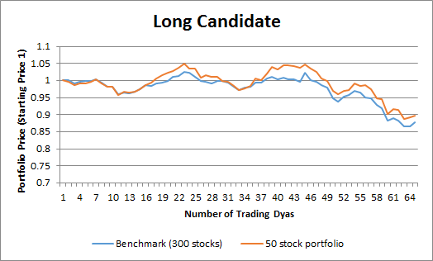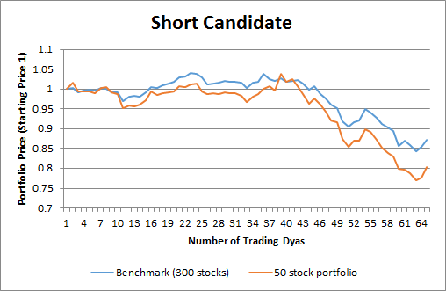

# IV Results

With a benchmark which is equal weighted return of initial candidates (300 long and 300 short stocks chosen by TAGA strategy) for long and short positions in a 130/30 fund, we plotted the blue line with a final holding period return of -12.18%. Based on our previous long portfolio and short portfolio, we created another 130/30 fund, which is also plotted as follows in orange, with a final holding period return of 7.50%.

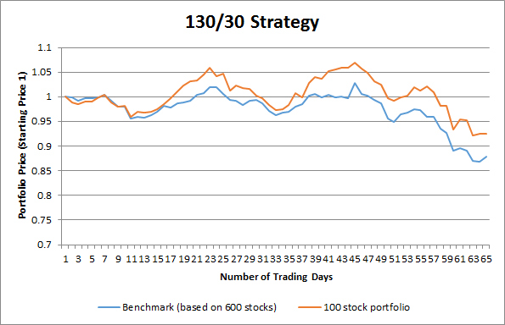

The result is rather straightforward. Our 100 stock portfolio beats the benchmark almost all the time during the chosen timeframe.